Uniform Polyhedron

Definition
# Source: AI Source: Provided by: [Data Path: Persons Table -> ID Column: 1, Name_En Column: Motasem Essam] -> From: [ChatGPT] on [7/25/2026]
A Uniform Polyhedron is a polyhedron whose faces are regular polygons and whose vertices are all geometrically equivalent under the symmetries of the solid.
This means that:
- Every face is a regular polygon, such as an equilateral triangle, square, or regular pentagon.
- Every vertex has an identical arrangement of faces.
- A symmetry operation can map any vertex onto any other vertex.
- All vertices have the same geometric configuration.
Uniform polyhedra may be convex or non-convex. Non-convex uniform polyhedra can contain star-shaped polygons and intersecting faces.

Geometric Structure
# Source: AI Source: Provided by: [Data Path: Persons Table -> ID Column: 1, Name_En Column: Motasem Essam] -> From: [ChatGPT] on [7/25/2026]
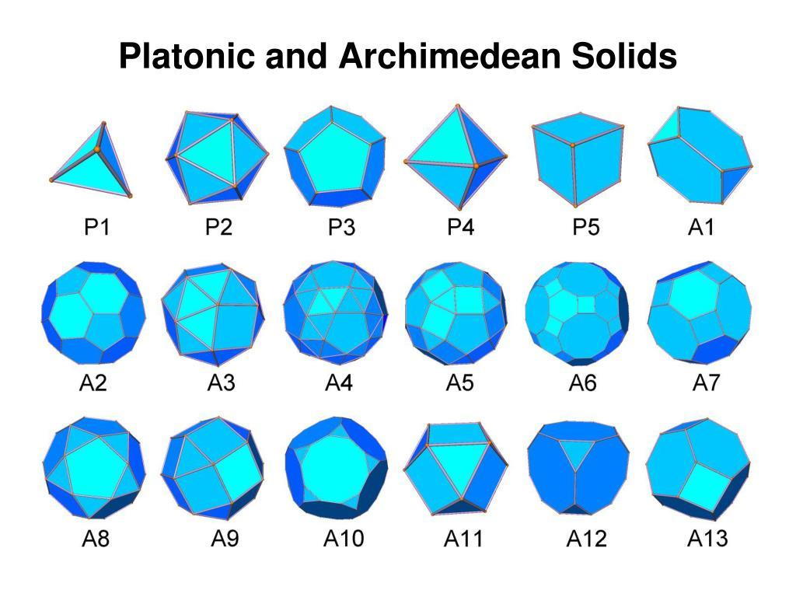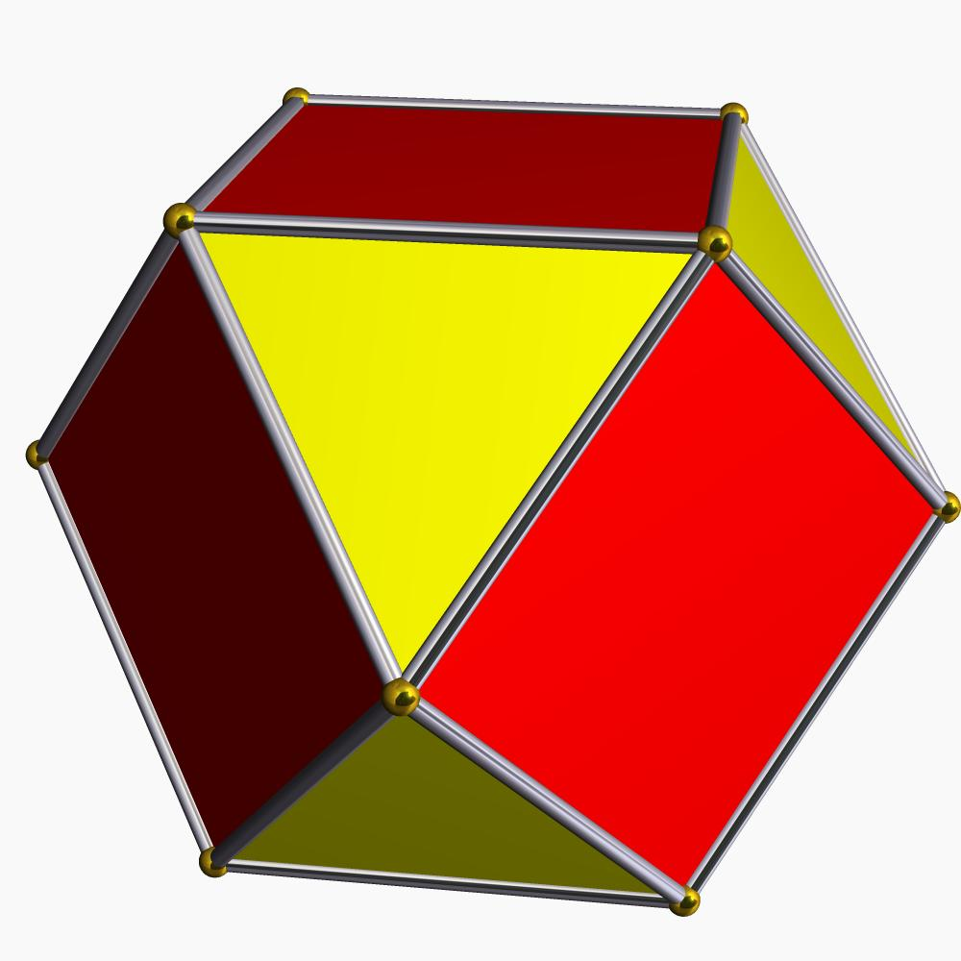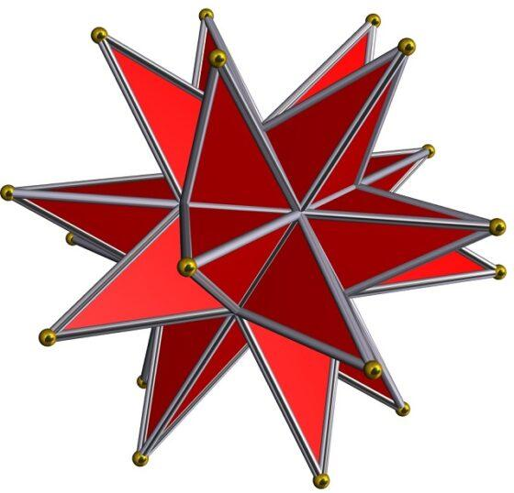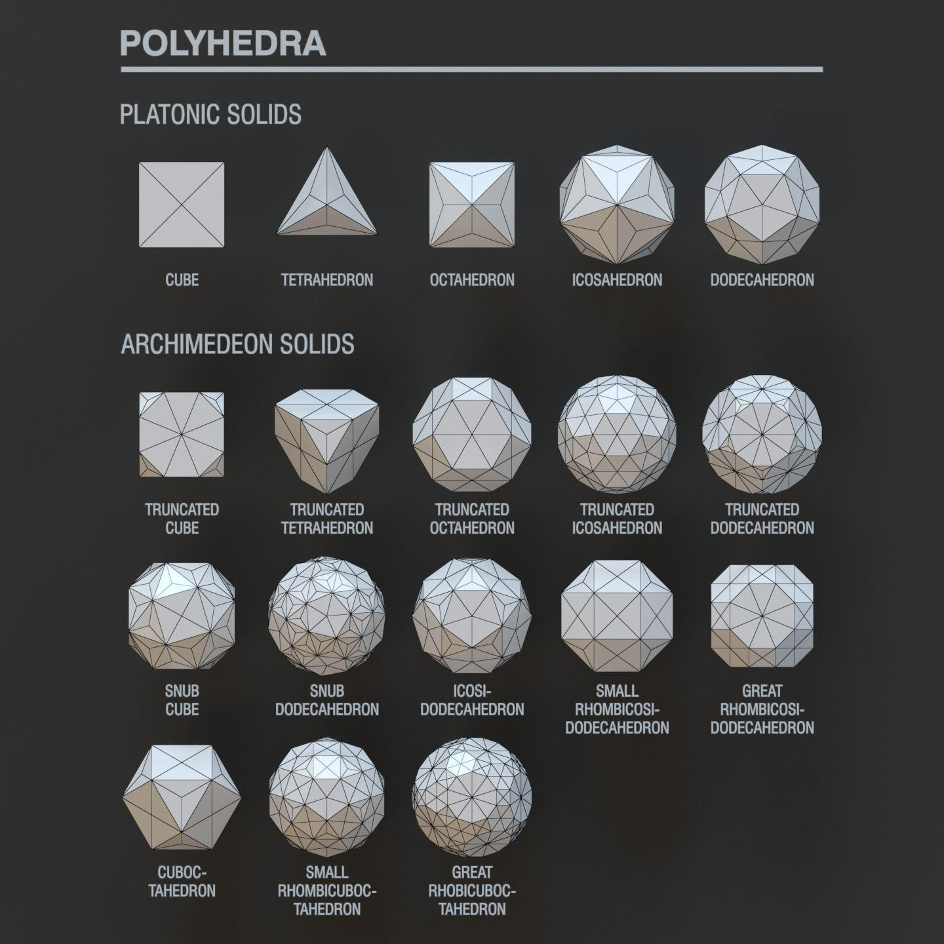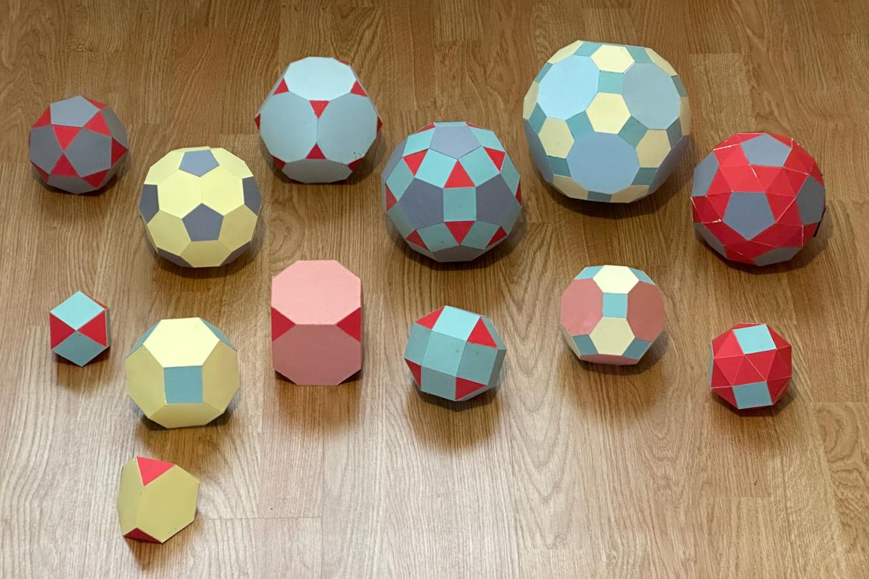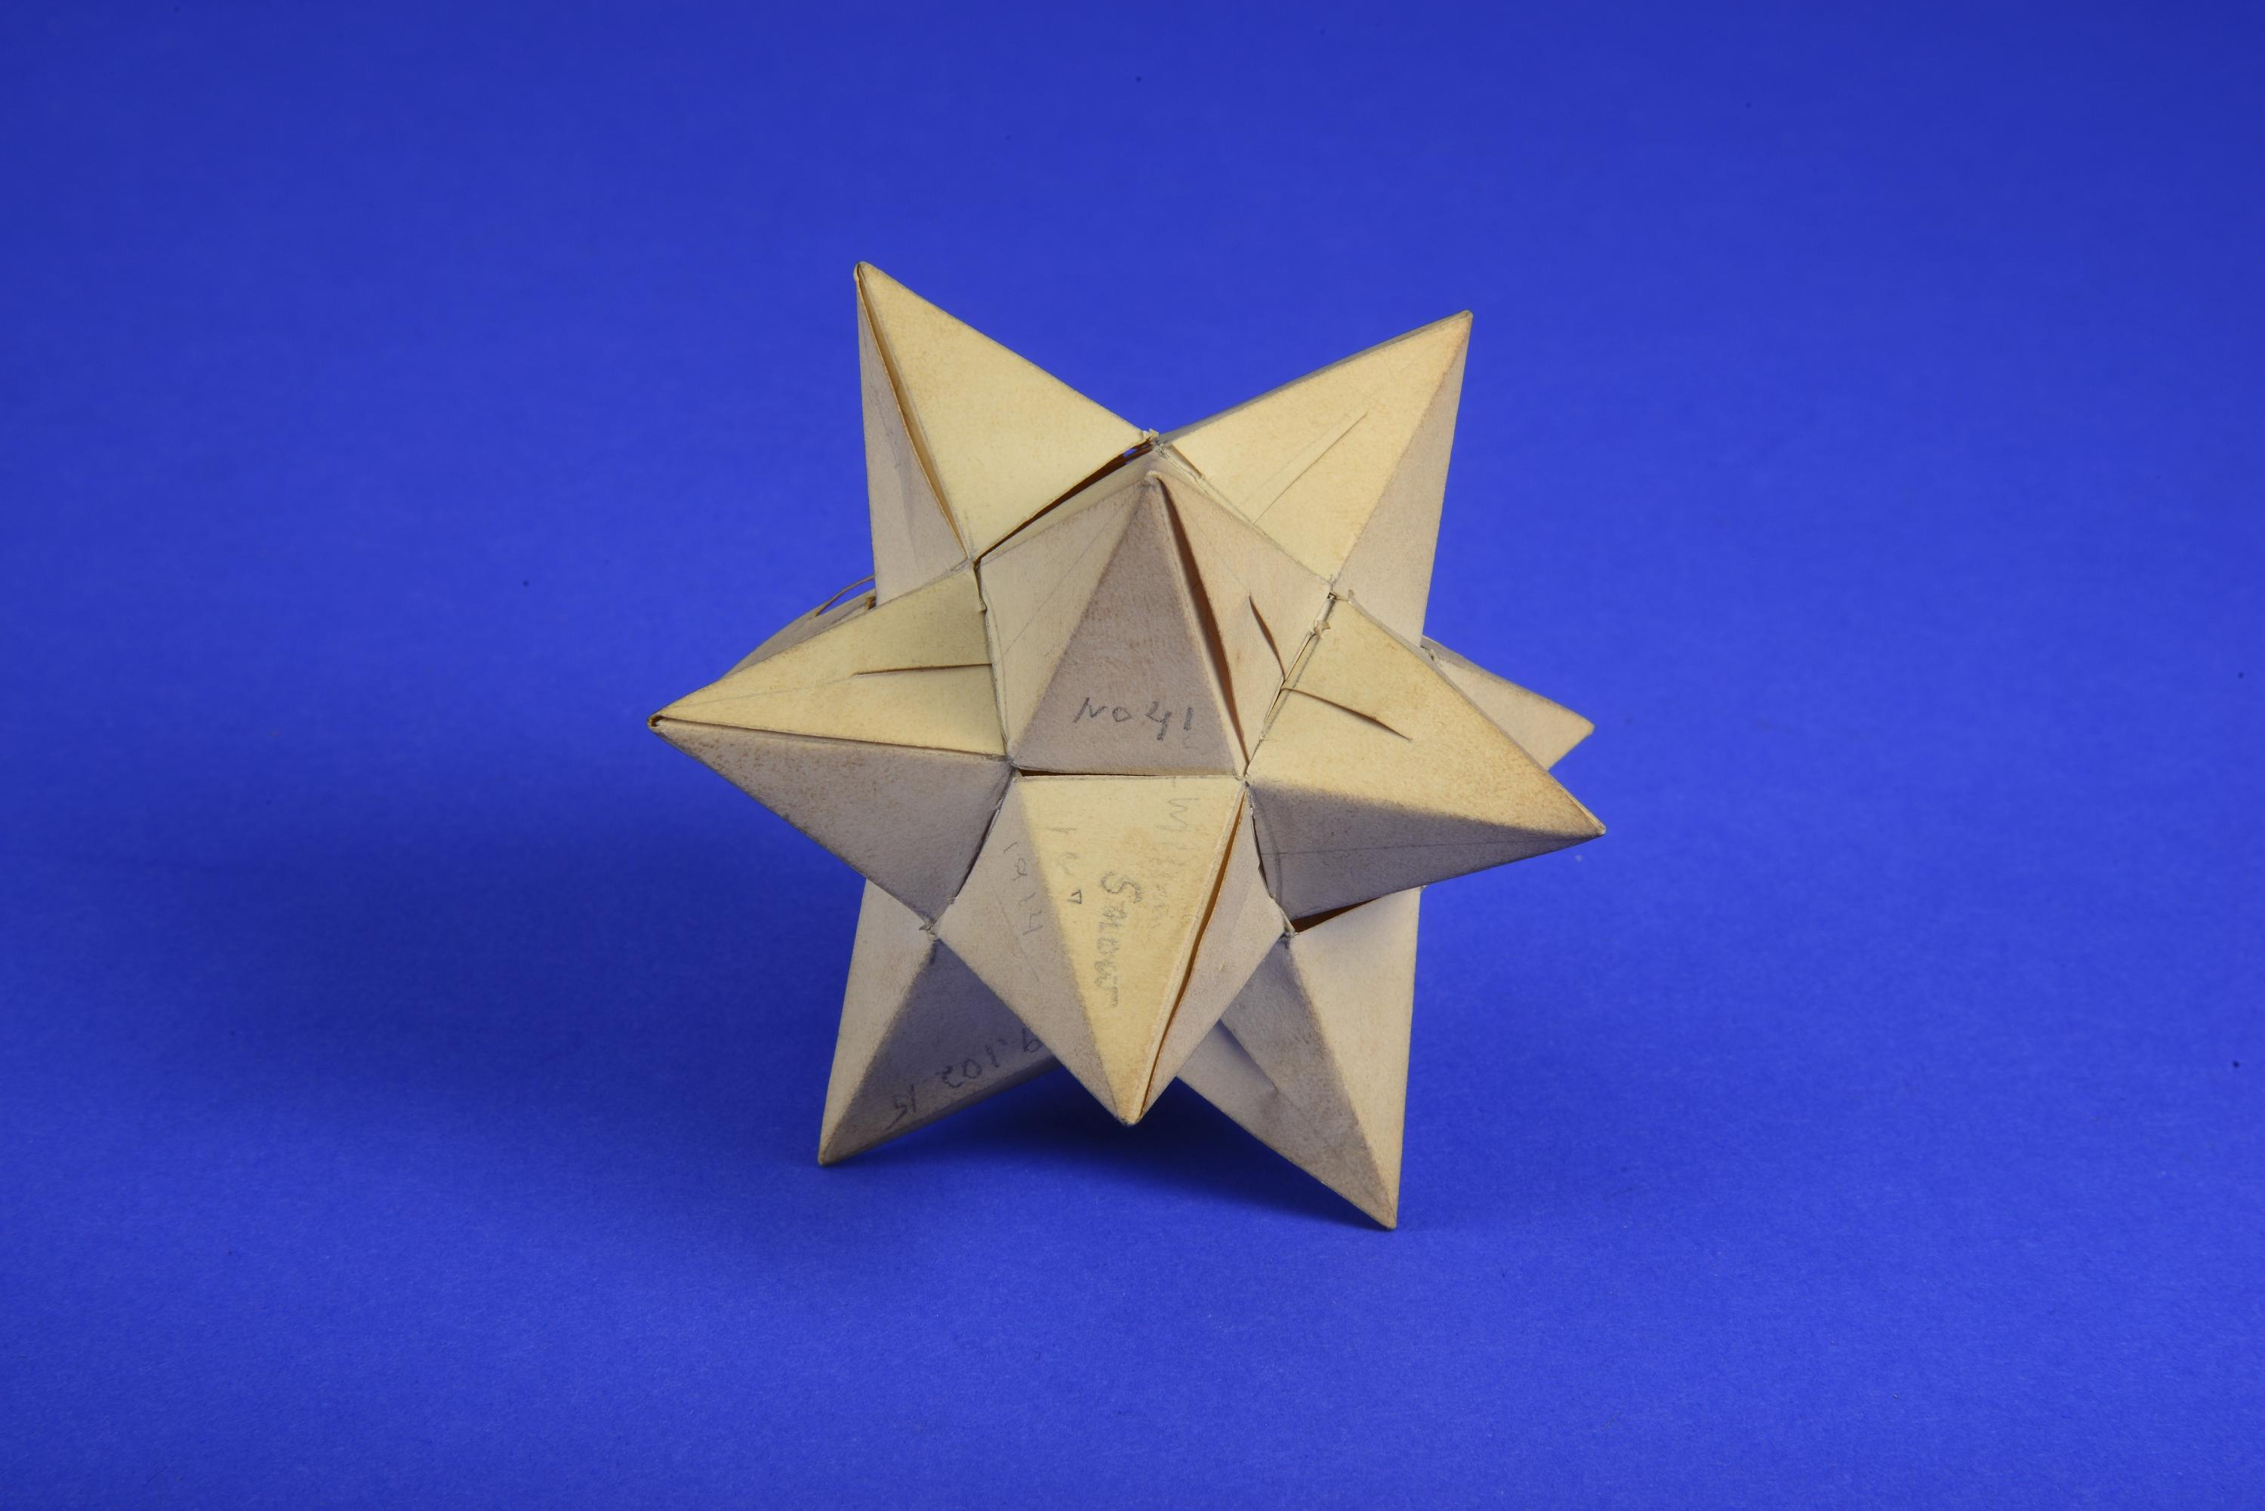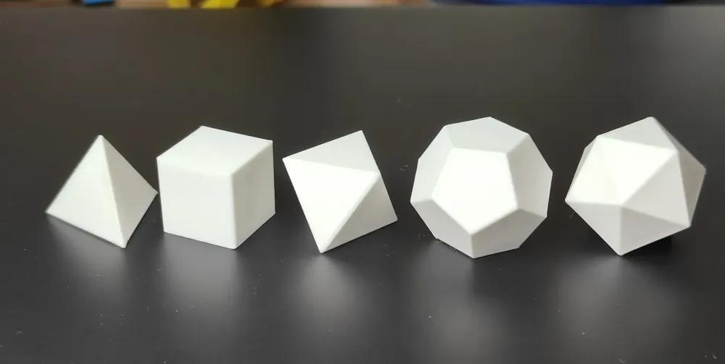
A uniform polyhedron is characterized by two important geometric properties:
Regular faces
Every face is a regular polygon or, in non-convex cases, a regular star polygon.
Vertex transitivity
Every vertex has an identical geometric arrangement. The same types of faces meet at every vertex in the same order.
For example, the cuboctahedron has the vertex configuration:
$$3.4.3.4$$
This means that two equilateral triangles and two squares meet alternately at every vertex.

Mathematical Properties
# Source: AI Source: Provided by: [Data Path: Persons Table -> ID Column: 1, Name_En Column: Motasem Essam] -> From: [ChatGPT] on [7/25/2026]
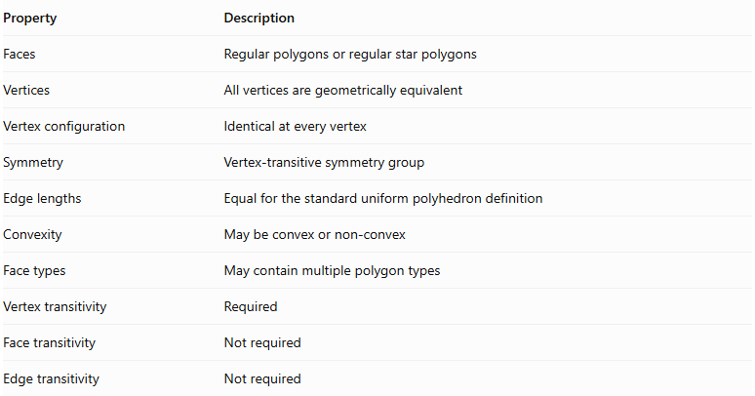
Property | Description
Faces | Regular polygons or regular star polygons
Vertices | All vertices are geometrically equivalent
Vertex configuration | Identical at every vertex
Symmetry | Vertex-transitive symmetry group
Edge lengths | Equal for the standard uniform polyhedron definition
Convexity | May be convex or non-convex
Face types | May contain multiple polygon types
Vertex transitivity | Required
Face transitivity | Not required
Edge transitivity | Not required

Vertex Configuration
# Source: AI Source: Provided by: [Data Path: Persons Table -> ID Column: 1, Name_En Column: Motasem Essam] -> From: [ChatGPT] on [7/25/2026]
The vertex configuration describes the sequence of polygon faces meeting around a vertex.
Examples:
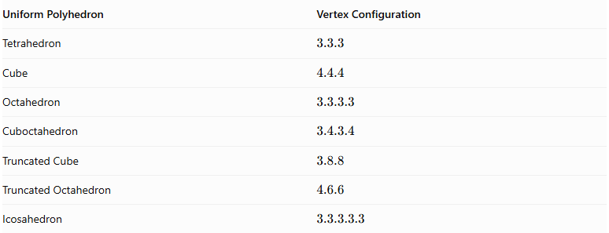
Uniform Polyhedron | Vertex Configuration
Tetrahedron | $$3.3.3$$
Cube | $$4.4.4$$
Octahedron | $$3.3.3.3$$
Cuboctahedron | $$3.4.3.4$$
Truncated Cube | $$3.8.8$$
Truncated Octahedron | $$4.6.6$$
Icosahedron | $$3.3.3.3.3$$

Types of Uniform Polyhedra
# Source: AI Source: Provided by: [Data Path: Persons Table -> ID Column: 1, Name_En Column: Motasem Essam] -> From: [ChatGPT] on [7/25/2026]
Uniform polyhedra can be organized into the following major classifications.

Convex Uniform Polyhedra
# Source: AI Source: Provided by: [Data Path: Persons Table -> ID Column: 1, Name_En Column: Motasem Essam] -> From: [ChatGPT] on [7/25/2026]
These are uniform polyhedra with convex faces and a convex overall shape.
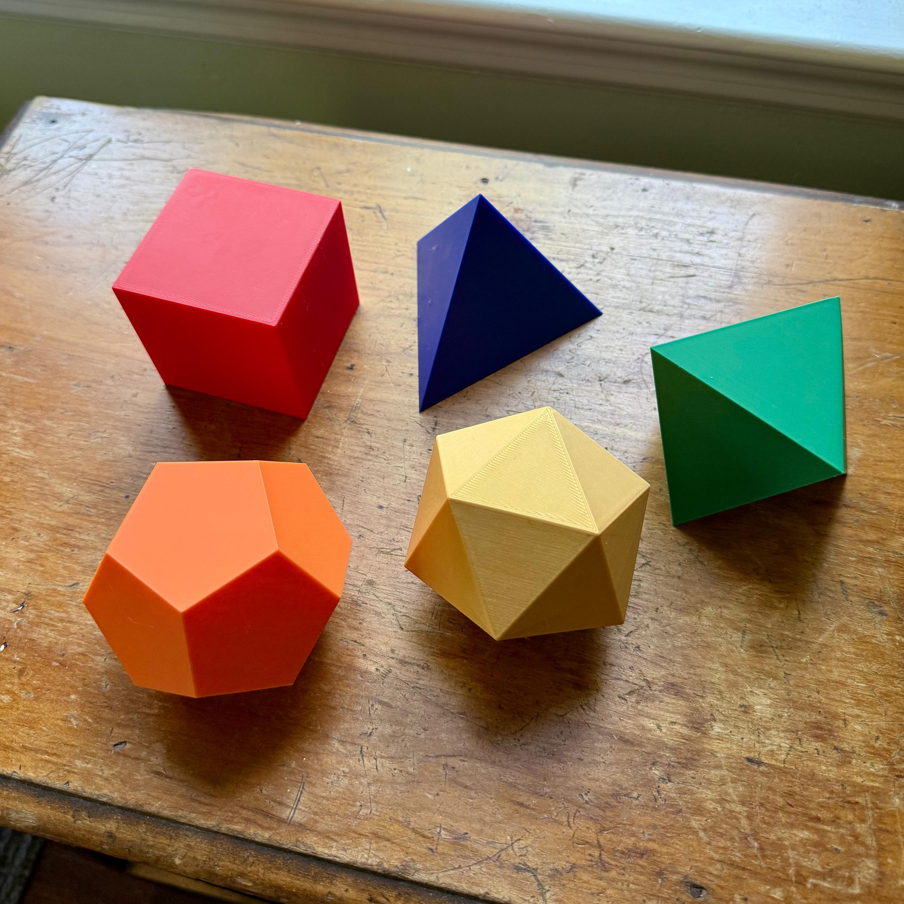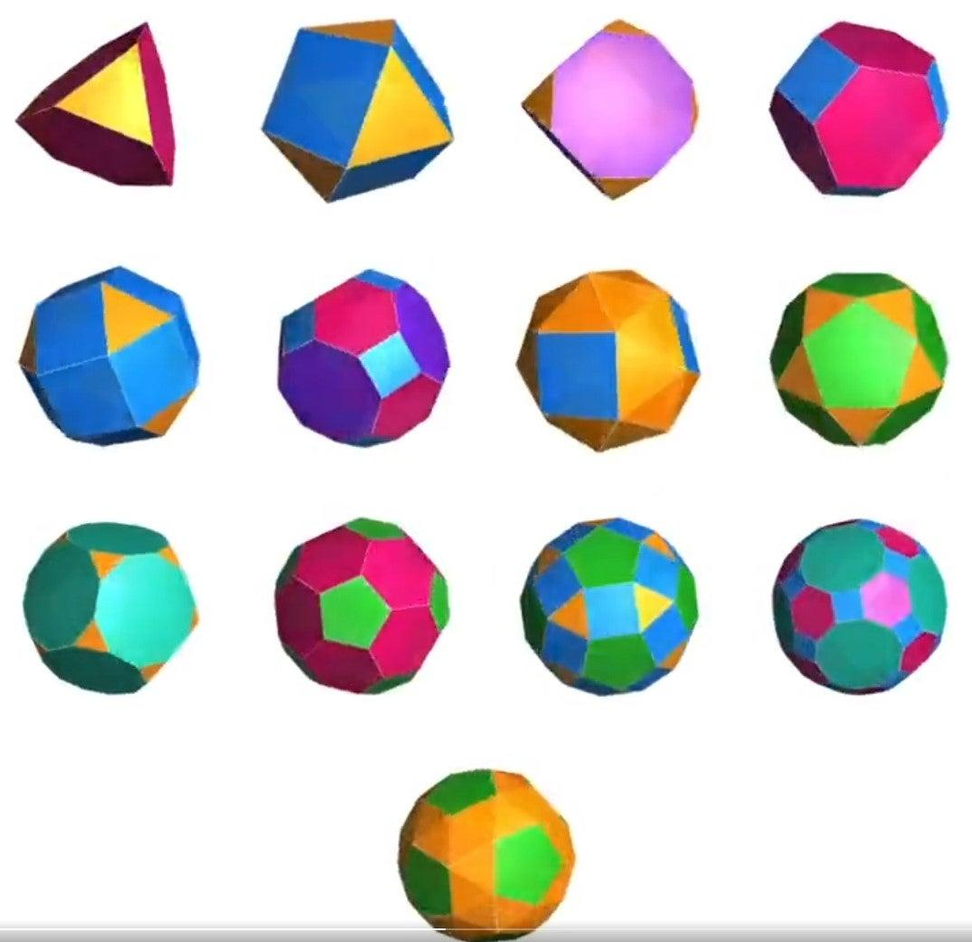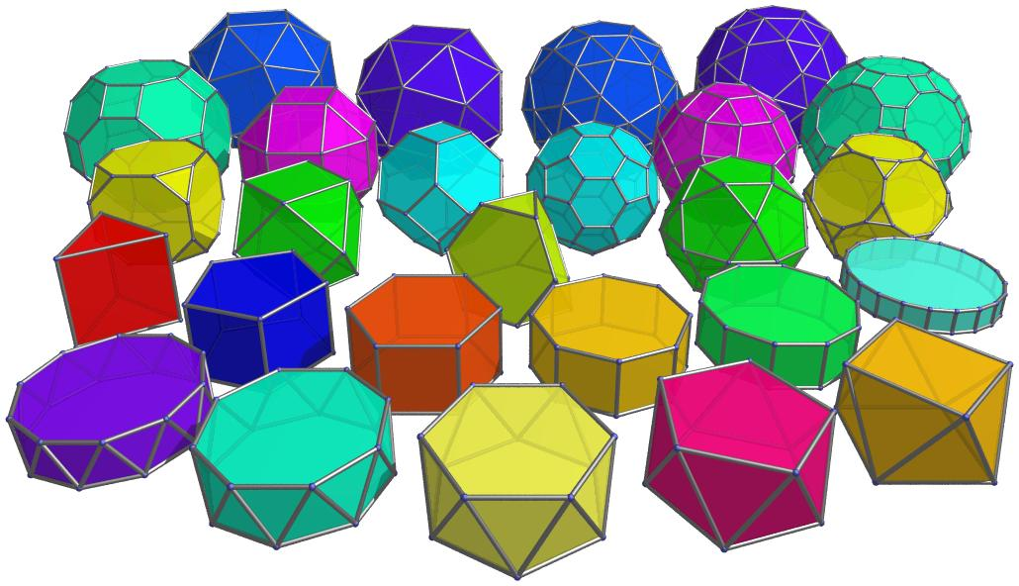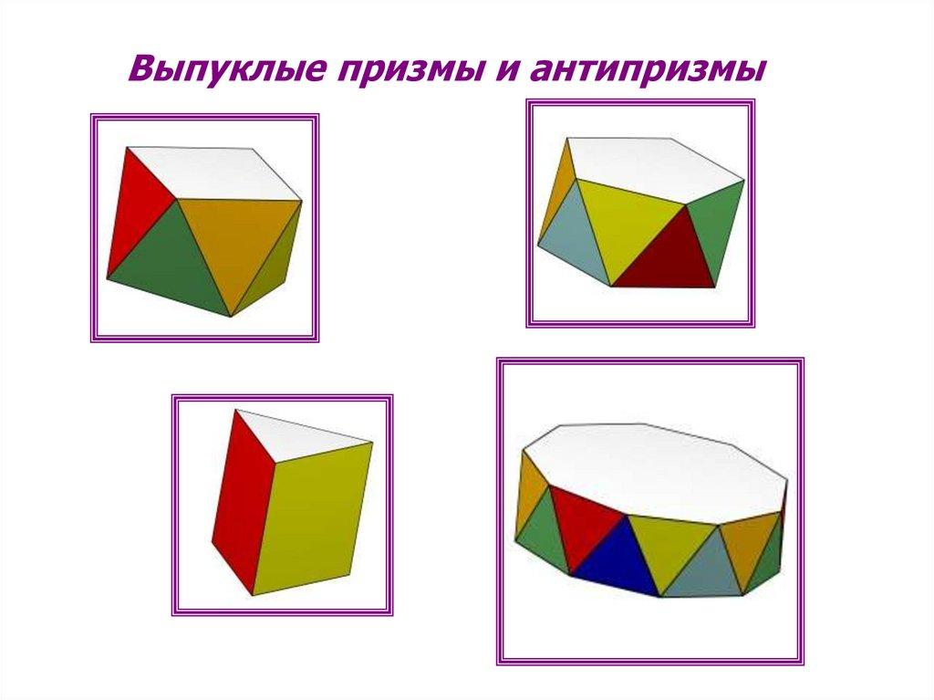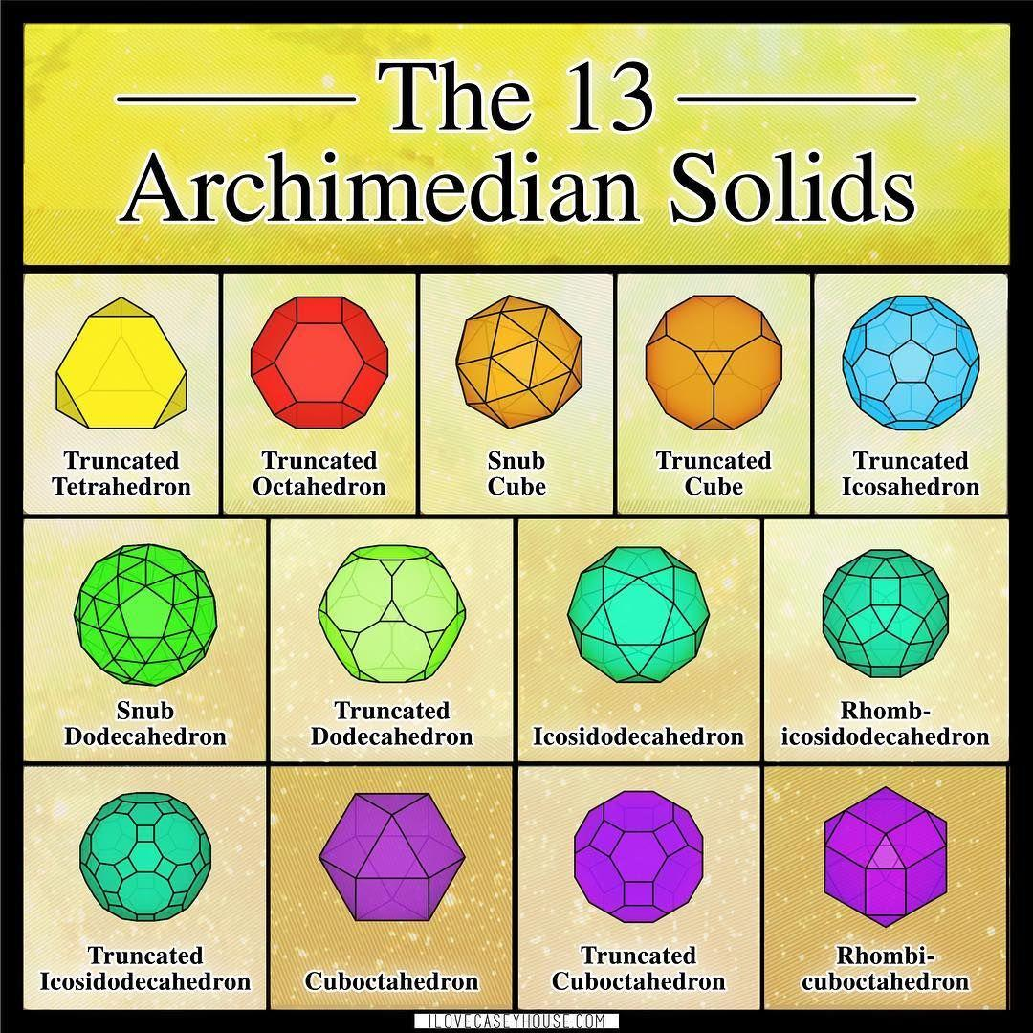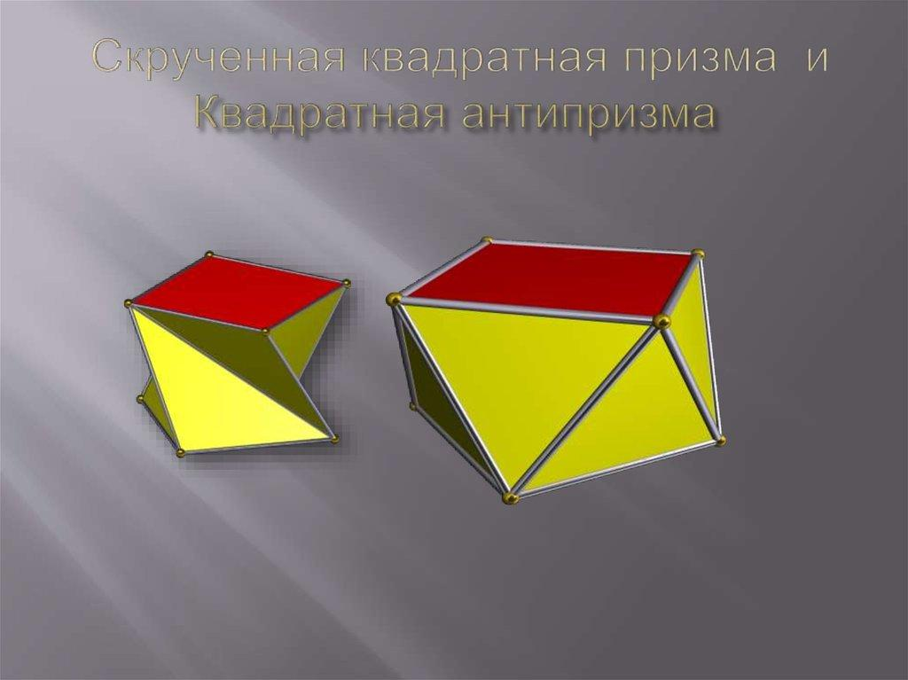

A. Platonic Solids
# Source: AI Source: Provided by: [Data Path: Persons Table -> ID Column: 1, Name_En Column: Motasem Essam] -> From: [ChatGPT] on [7/25/2026]
The five regular convex polyhedra. Every face is the same regular polygon, and every vertex has the same configuration.
- Tetrahedron
- Cube
- Octahedron
- Dodecahedron
- Icosahedron

B. Archimedean Solids
# Source: AI Source: Provided by: [Data Path: Persons Table -> ID Column: 1, Name_En Column: Motasem Essam] -> From: [ChatGPT] on [7/25/2026]
The thirteen convex semiregular polyhedra, which have two or more types of regular polygonal faces.
Examples include:
- Truncated Tetrahedron
- Cuboctahedron
- Truncated Cube
- Truncated Octahedron
- Rhombicuboctahedron
- Truncated Cuboctahedron
- Snub Cube
- Icosidodecahedron
- Truncated Dodecahedron
- Truncated Icosahedron
- Rhombicosidodecahedron
- Truncated Icosidodecahedron
- Snub Dodecahedron

C. Uniform Prisms
# Source: AI Source: Provided by: [Data Path: Persons Table -> ID Column: 1, Name_En Column: Motasem Essam] -> From: [ChatGPT] on [7/25/2026]
An infinite family of convex uniform polyhedra constructed from two parallel, congruent regular polygonal bases connected by rectangular lateral faces.
Examples:
- Triangular Prism
- Square Prism
- Pentagonal Prism
- Hexagonal Prism
- N-gonal Prism

D. Uniform Antiprisms
# Source: AI Source: Provided by: [Data Path: Persons Table -> ID Column: 1, Name_En Column: Motasem Essam] -> From: [ChatGPT] on [7/25/2026]
An infinite family of convex uniform polyhedra constructed from two parallel, congruent regular polygonal bases connected by alternating equilateral triangular faces.
Examples:
- Triangular Antiprism
- Square Antiprism
- Pentagonal Antiprism
- Hexagonal Antiprism
- N-gonal Antiprism

Non-Convex Uniform Polyhedra
# Source: AI Source: Provided by: [Data Path: Persons Table -> ID Column: 1, Name_En Column: Motasem Essam] -> From: [ChatGPT] on [7/25/2026]
These are uniform polyhedra that have non-convex geometry, often involving star polygons, intersecting faces, or star-shaped vertex arrangements.
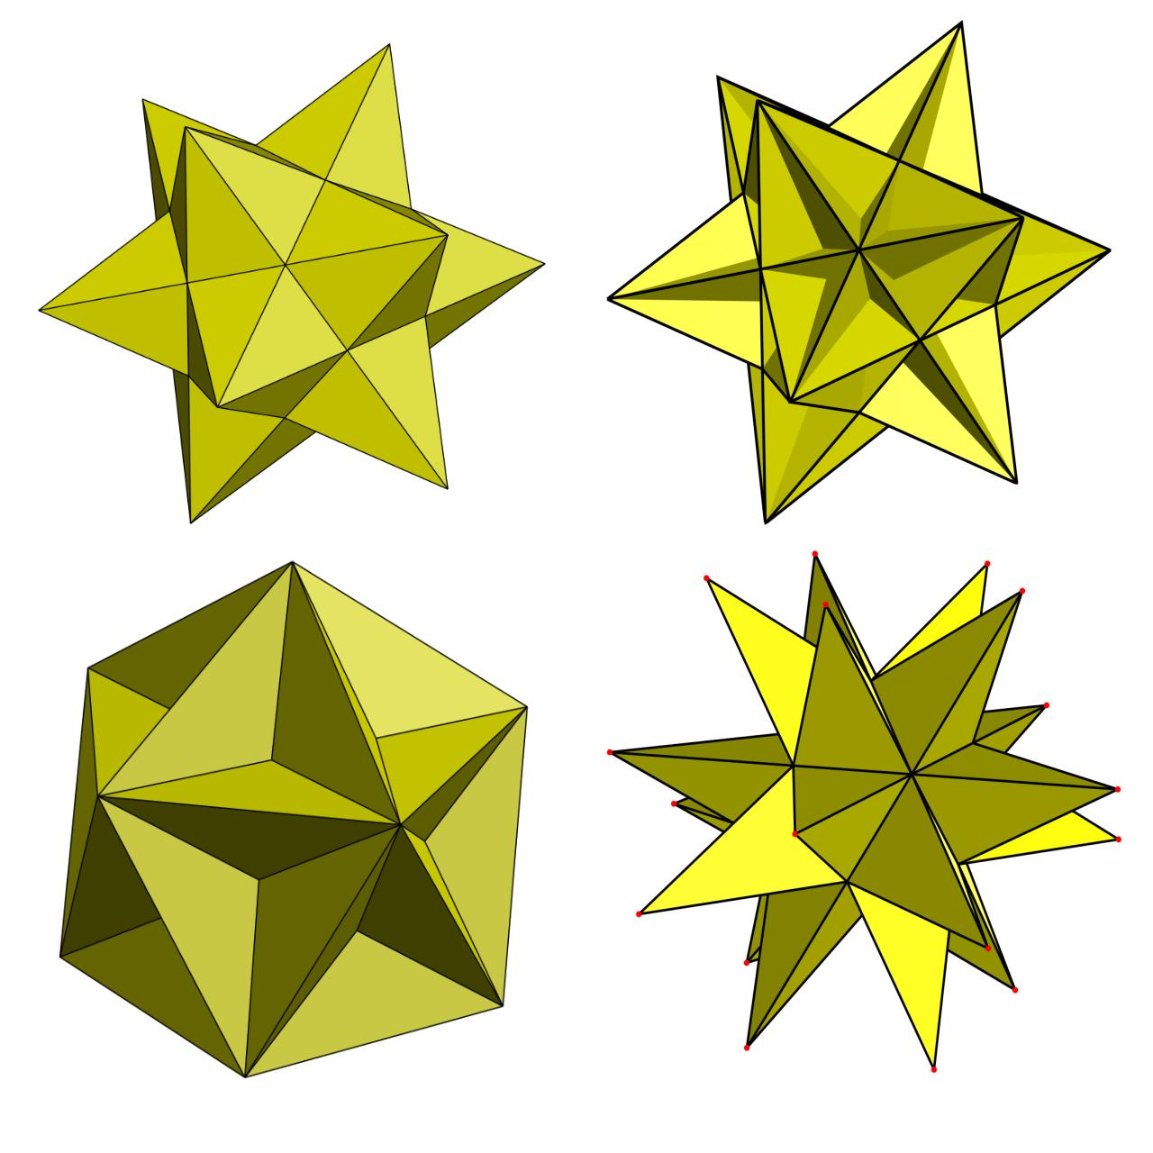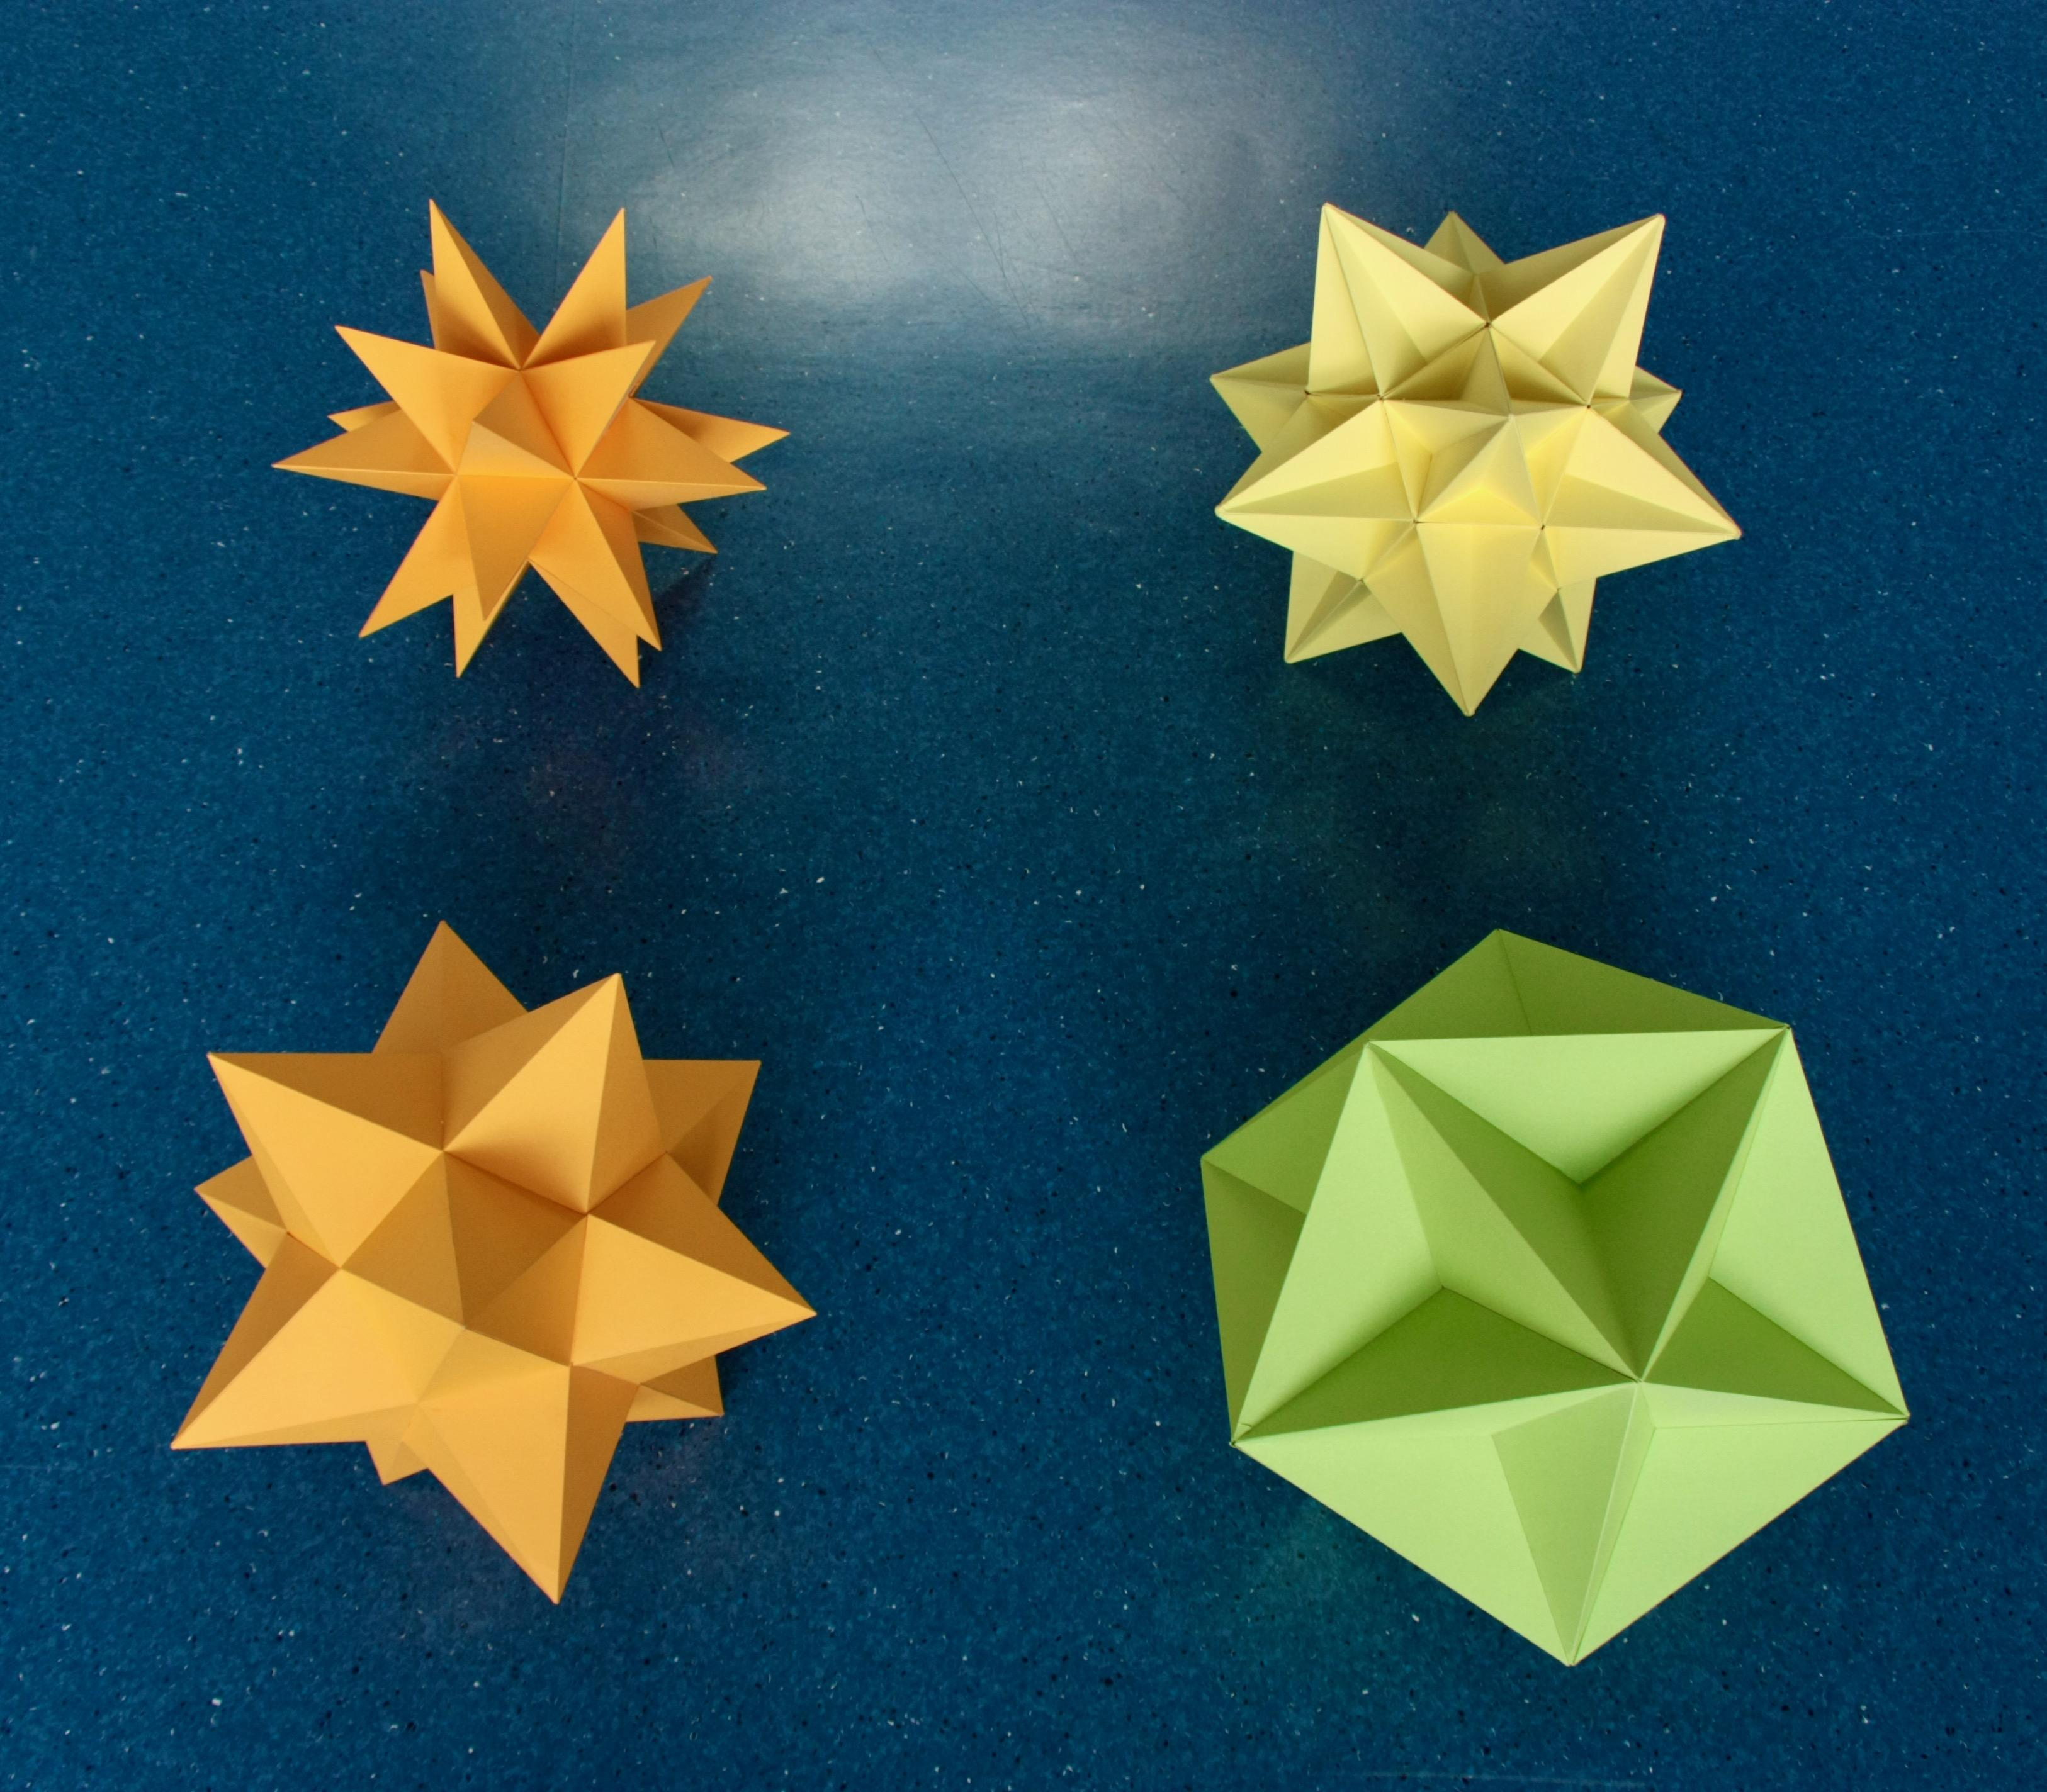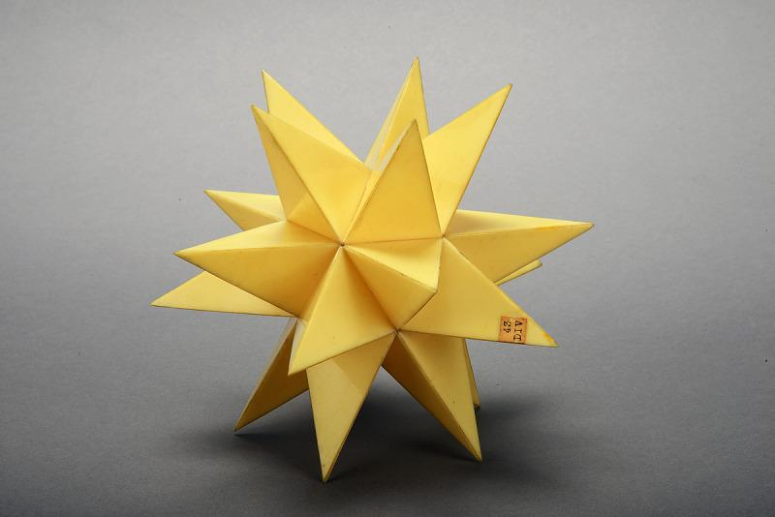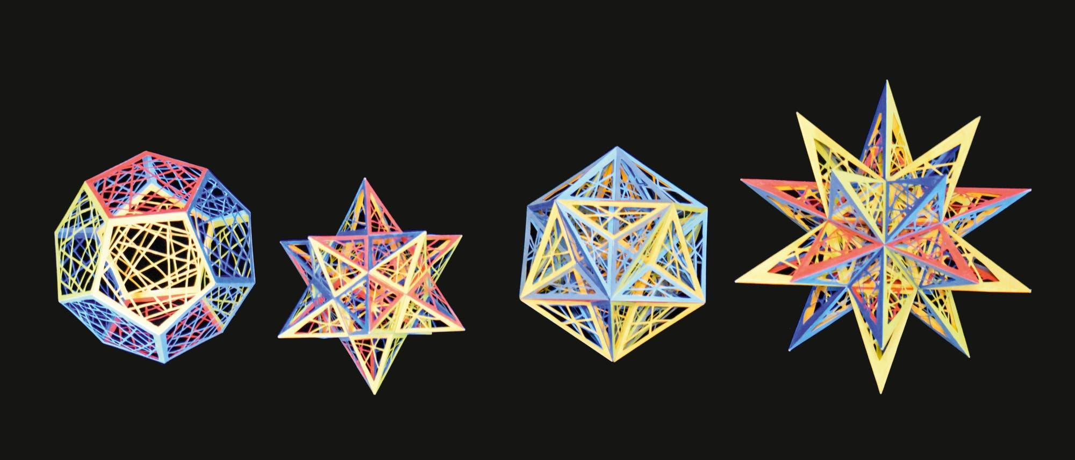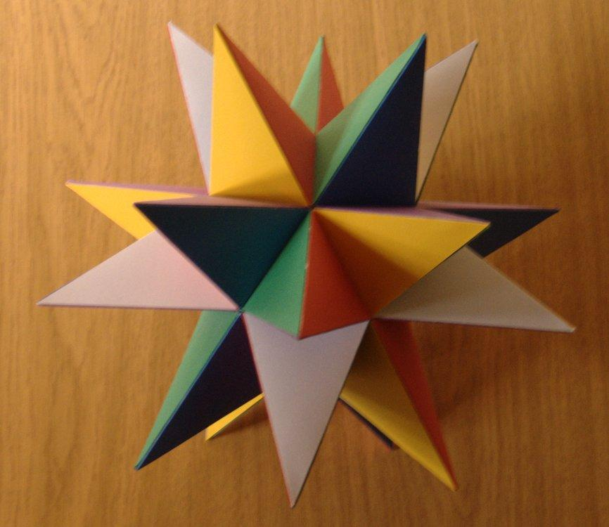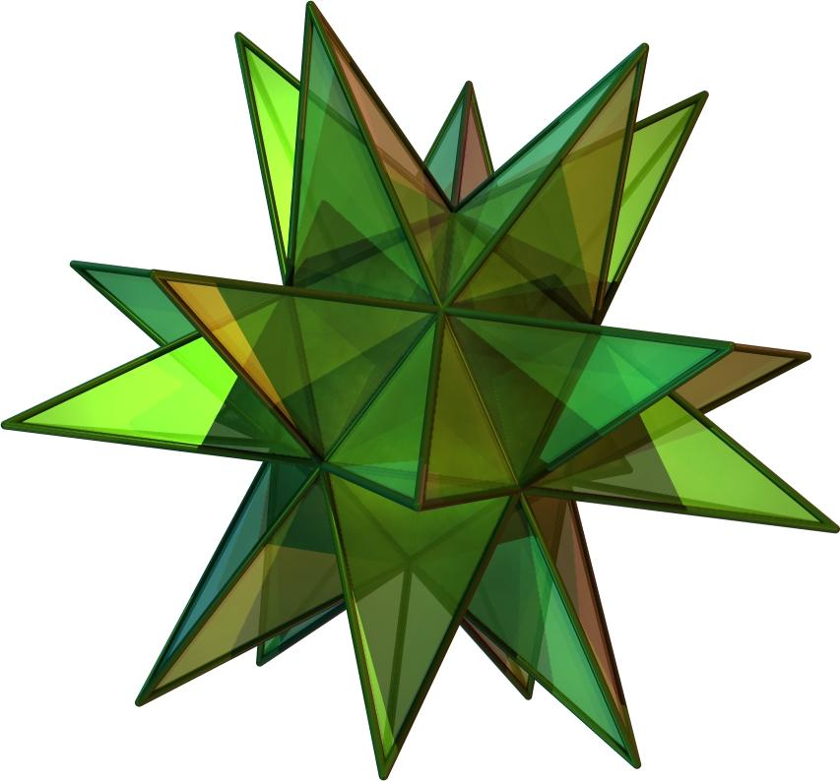

A. Kepler–Poinsot Polyhedra
# Source: AI Source: Provided by: [Data Path: Persons Table -> ID Column: 1, Name_En Column: Motasem Essam] -> From: [ChatGPT] on [7/25/2026]
The four regular non-convex star polyhedra:
- Small Stellated Dodecahedron
- Great Dodecahedron
- Great Stellated Dodecahedron
- Great Icosahedron

B. Uniform Star Polyhedra
# Source: AI Source: Provided by: [Data Path: Persons Table -> ID Column: 1, Name_En Column: Motasem Essam] -> From: [ChatGPT] on [7/25/2026]
Non-convex uniform polyhedra that are not regular, including solids with regular star-polygon faces or star-shaped vertex configurations.
Examples include:
- Small Cubicuboctahedron
- Great Cubicuboctahedron
- Great Rhombicuboctahedron
- Small Icosicosidodecahedron
- Great Icosicosidodecahedron
- Snub Dodecadodecahedron

Classification According to Symmetry
# Source: AI Source: Provided by: [Data Path: Persons Table -> ID Column: 1, Name_En Column: Motasem Essam] -> From: [ChatGPT] on [7/25/2026]
Uniform polyhedra can also be classified according to their symmetry properties.
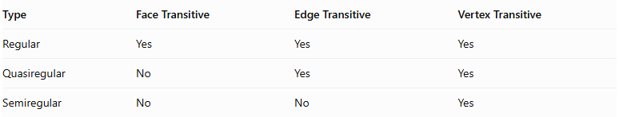
Type | Face Transitive | Edge Transitive | Vertex Transitive
Regular | Yes | Yes | Yes
Quasiregular | No | Yes | Yes
Semiregular | No | No | Yes
A. Regular Polyhedra
All faces, edges, and vertices are equivalent under the symmetry group.
Example: Cube.
B. Quasiregular Polyhedra
All edges and vertices are equivalent, but the faces belong to different symmetry classes.
Examples: Cuboctahedron and Icosidodecahedron.
C. Semiregular Polyhedra
All vertices are equivalent, but the edges and faces are not necessarily equivalent.
Example: Truncated Cube.
This classification describes symmetry properties, not convexity.

Geometric Characteristics
# Source: AI Source: Provided by: [Data Path: Persons Table -> ID Column: 1, Name_En Column: Motasem Essam] -> From: [ChatGPT] on [7/25/2026]
- Regular polygonal faces: Every face is a regular polygon or regular star polygon.
- Vertex transitivity: Every vertex is equivalent under the symmetry group.
- Uniform vertex arrangement: The same face sequence occurs around every vertex.
- Symmetry: Uniform polyhedra possess rotational and/or reflectional symmetries.
- Convexity: Uniform polyhedra may be convex or non-convex.
- Multiple face types: A uniform polyhedron may contain several different regular polygon types.
- Star geometry: Some uniform polyhedra contain star polygons or intersecting faces.

Number and Classification of Uniform Polyhedra
# Source: AI Source: Provided by: [Data Path: Persons Table -> ID Column: 1, Name_En Column: Motasem Essam] -> From: [ChatGPT] on [7/25/2026]
Under the classical classification of uniform polyhedra:
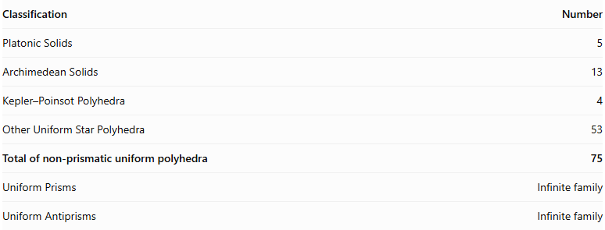
Classification | Number
Platonic Solids | 5
Archimedean Solids | 13
Kepler–Poinsot Polyhedra | 4
Other Uniform Star Polyhedra | 53
Total of non-prismatic uniform polyhedra | 75
Uniform Prisms | Infinite family
Uniform Antiprisms | Infinite family
The total of 75 excludes the two infinite families of prisms and antiprisms.

Related Geometric Concepts
# Source: AI Source: Provided by: [Data Path: Persons Table -> ID Column: 1, Name_En Column: Motasem Essam] -> From: [ChatGPT] on [7/25/2026]
- Regular Polyhedron: A polyhedron with identical regular faces and equivalent vertices and edges.
- Semiregular Polyhedron: A polyhedron with regular polygonal faces and equivalent vertices.
- Archimedean Solid: One of the thirteen convex semiregular uniform polyhedra.
- Platonic Solid: One of the five regular convex uniform polyhedra.
- Star Polyhedron: A non-convex polyhedron involving star polygons or intersecting geometry.
- Vertex-Transitive Polyhedron: A polyhedron whose symmetry group can map any vertex onto any other vertex.
- Dual Polyhedron: A polyhedron formed by exchanging the roles of faces and vertices; the dual of a uniform polyhedron is generally face-transitive.

Important Distinction: Uniform Polyhedron vs. Johnson Solid
# Source: AI Source: Provided by: [Data Path: Persons Table -> ID Column: 1, Name_En Column: Motasem Essam] -> From: [ChatGPT] on [7/25/2026]
Not every polyhedron with regular polygonal faces is uniform.
For example:
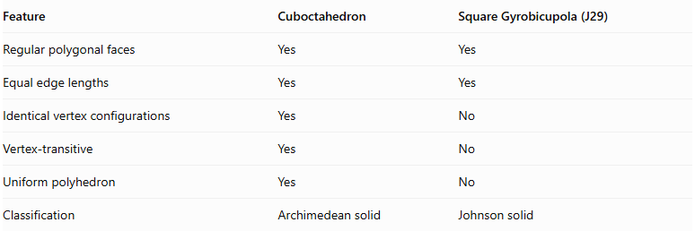
Feature | Cuboctahedron | Square Gyrobicupola (J29)
Regular polygonal faces | Yes | Yes
Equal edge lengths | Yes | Yes
Identical vertex configurations | Yes | No
Vertex-transitive | Yes | No
Uniform polyhedron | Yes | No
Classification | Archimedean solid | Johnson solid
The Square Gyrobicupola has two different vertex configurations, so it does not satisfy the vertex-transitivity requirement of a uniform polyhedron.

Main Classification
# Source: AI Source: Provided by: [Data Path: Persons Table -> ID Column: 1, Name_En Column: Motasem Essam] -> From: [ChatGPT] on [7/25/2026]
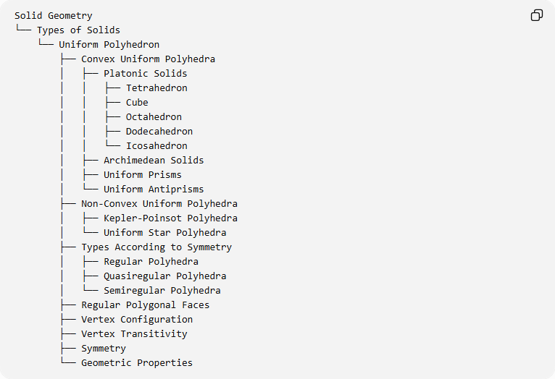
Solid Geometry
└── Types of Solids
└── Uniform Polyhedron
├── Convex Uniform Polyhedra
│ ├── Platonic Solids
│ │ ├── Tetrahedron
│ │ ├── Cube
│ │ ├── Octahedron
│ │ ├── Dodecahedron
│ │ └── Icosahedron
│ ├── Archimedean Solids
│ ├── Uniform Prisms
│ └── Uniform Antiprisms
├── Non-Convex Uniform Polyhedra
│ ├── Kepler-Poinsot Polyhedra
│ └── Uniform Star Polyhedra
├── Types According to Symmetry
│ ├── Regular Polyhedra
│ ├── Quasiregular Polyhedra
│ └── Semiregular Polyhedra
├── Regular Polygonal Faces
├── Vertex Configuration
├── Vertex Transitivity
├── Symmetry
└── Geometric Properties

Key Points
# Source: AI Source: Provided by: [Data Path: Persons Table -> ID Column: 1, Name_En Column: Motasem Essam] -> From: [ChatGPT] on [7/25/2026]
- A uniform polyhedron must have regular polygonal or regular star-polygon faces.
- All vertices must be equivalent under the symmetries of the polyhedron.
- Uniform polyhedra can be convex or non-convex.
- The Platonic and Archimedean solids are convex uniform polyhedra.
- Prisms and antiprisms form two infinite families of convex uniform polyhedra.
- The classical classification contains 75 non-prismatic uniform polyhedra.
- Johnson solids are not automatically uniform.

Conclusion
# Source: AI Source: Provided by: [Data Path: Persons Table -> ID Column: 1, Name_En Column: Motasem Essam] -> From: [ChatGPT] on [7/25/2026]
A Uniform Polyhedron is a broad geometric classification based on regular faces and vertex transitivity. It includes the Platonic solids, Archimedean solids, uniform prisms, uniform antiprisms, and non-convex uniform star polyhedra.
I can also organize the 13 Archimedean solids and their individual types into a separate hierarchy for your Solid Geometry taxonomy.

